Name: ______________________________

The Crusades: The Crescent & the Cross
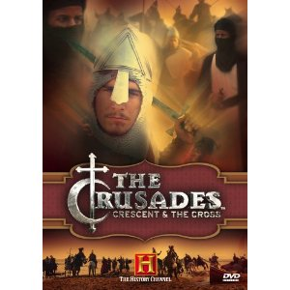
Directions: As you watch the video, answer the questions below about the First Crusade. If the question calls for sentences, please write full sentences. The minutes written in brackets next to questions are the approximate times the answer will appear. (Not all questions are answered directly in the video!)

(:30) 1. What did the Crusaders fight over? (1 pt.) _______________________________. How long did they fight for/ over this? (How many years?) (1 pt.) _____________________.

(1:00) 2. What two groups fought during the Crusades? (2 pts.) ______________________ & ____________________________.

(2:20) 3. Why is Jersalem important to Jews? (1 pt.) ________________________________
_____________________________________________________________________.

(2:22) 4. Why is Jerusalem important to Muslims? (What happened there?) (1 pt.) _________
_______________________________________________________________________.

(2:24) 5. Why is Jerusalem important to Christians? (What happened there?) (1 pt.) ________
_______________________________________________________________________.

(3:40) 6. Why did Duke Godfrey start the First Crusade? (What did he hope to do?) (1 pt.)
_______________________________________________________________________.

(5:00) 7. How does Dr. Phillips describe Europe during the Medieval era? (Name 2 things he says.) (1 pt. each) ____________________________________________________________
______________________________________________________________________.

(5:15) 8. How does William of Tyre describe this era? (Name 2 things he says.) (1 pt. each)
______________________________________________________________________
______________________________________________________________________.

(6:25) 9. What “dominates the world of the Middle Ages”? (1 pt.) _____________________________________________________________________________.

(7:30) 10. Who became the Pope in 1088 C.E.? (1 pt.) ________________________________.

(8:19) 11. Where did the “urgent plea for help” come from (to the Pope) in 1095 C.E.? (What city or country?) (1 pt.) _________________________________________________________.

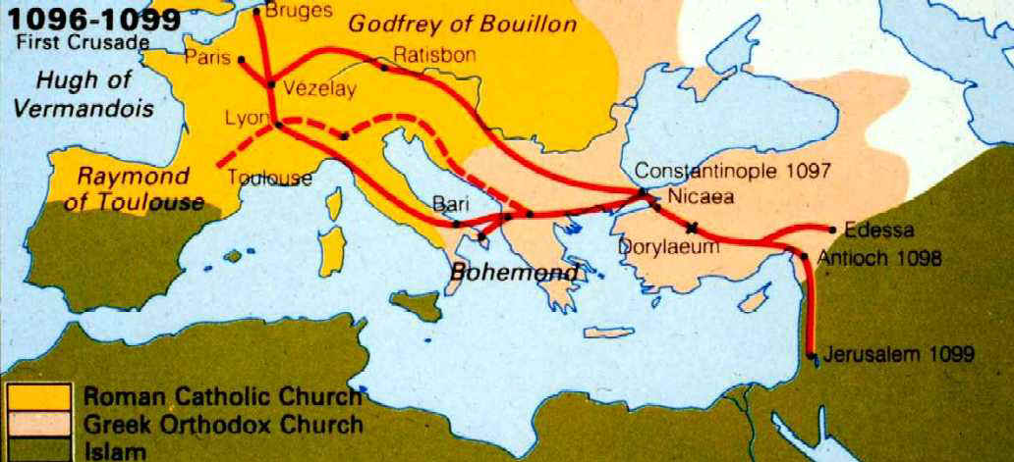
Photo: Map of the route of the First Crusade.

(8:30) 12. What was the name of the Byzantine emperor in 1095 C.E.? (1 pt.) ______________________________________. What troubles did he face? (1 pt.) ________________________________________________________________________
_______________________________________________________________________.

(8:50) 13. What did the Salyut Turks want around this time? (1 pt.) _____________________.

(10:00) 14. How much political power did popes of this time have? (1 pt.) _________________
_____________________________. How did the pope (in 1095 C.E.) plan to use the power he had? (What were his goals?) (1 pt.) _________________________________
_______________________________________________________________________.

(12:45) 15. What does the pope say about the Saracens (Turks) in his sermon in France in 1095 C.E.? Name 2 things “William of Tyre” reads from the scroll. (1 pt. each)
_______________________________________________________________________.
_______________________________________________________________________.

(13:00) 16. How powerful was the pope’s sermon? (What did people do right after hearing him speak?) (1 pt.) __________________________________________________________.

(15:20) 17. Besides gold and land, what does “William of Tyre” say drove people to take the pledge and go on Crusade? (What does the pope offer them?) (1 pt.) ________________
_______________________________________________________________________.

(16:25) 18. Which Commandment does the narrator say the pope gave Crusaders permission to break? (1 pt.) ___________________________________________________________.

(17:15) 19. Who did the Crusaders (“Pilgrims”) take out their anger on first? (Which group of people did the Crusaders attack first?) Why? (1 pt. each) _________________________
________________________________________________________________________
________________________________________________________________________
_______________________________________________________________________.

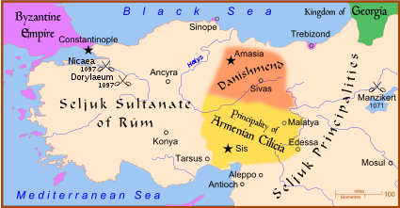
Photo: Photo: Map of the Battle of Dorylaeum (upper left corner of map).

(20:15) 20. What does Professor France say about the conditions of the Crusaders? What things did they sacrifice to go on Crusade?
Who went along with the “rich man” on Crusade? (1 pt. each) _______________________________________________________________________
_______________________________________________________________________.
Why did these other people go (according to Professor France)? (1 pt.) ______________
________________________________________________________________________
_______________________________________________________________________.

(21:45) 21. What is Constantinople called today? (1 pt.) ______________________________. What religion do most people who live there practice? (1 pt.) _____________________.
Why was this city an important sign post to Crusaders? (What did it represent?) (1 pt.)
_______________________________________________________________________.
What happened when Crusaders first came to the city gates of Constantinople? (1 pt.)
_______________________________________________________________________.

(28:00) 22. What did the Byzantine emperor make the 3 Christian commanders do to get food for their army? (1 pt.) _________________________________________. How did this change things for the Crusaders? (1 pt.) _______________________________________
________________________________________________________________________
_______________________________________________________________________.

(31:30 – 32:00) 23. What do the Byzantines do at Nicaea that really angers the Crusaders?
(1 pt.) _______________________________________________________________________.

(35:00) 24. What happened to part of the Crusader army after the incident at Nicaea? (1 pt.) _______________________________________________________. Why was the spot they chose a “bad place” to camp? (1 pt.) _____________________________________
_______________________________________________________________________.

(39:00) 25. What “secret weapon” have researchers learned about recently using primary sources? (Spell the name as best as you can.) (1 pt.) ____________________________. What did these warriors do? (1 pt.) __________________________________________
_______________________________________________________________________.

